External Conflict Essay

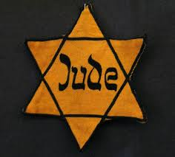 V.S
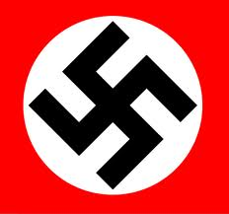

By: Dakota Lynn Date: 4-24-13 Class:8:C

Are We Really That Different
Are we really that different? I mean a religion shouldn't define your social status should it? I believe NOT, here are the distinct differences and similarities of the Jewish community and the Germans. The Jewish were looked down upon, and weren't treated any better than an animal; some were treated worse than an animal. The Jewish were locked up in a “cage” and taken to concentration camps to be forced to work and follow orders simply because they were Jewish. Where the German’s sat back and gave orders because that’s what they were told to do. The Jewish could not free handedly kill a German because they wanted to, unlike the Germans. The Germans could kill anyone that was Jewish, and were actually encouraged to. The Jewish were starved, where the Germans were not. The Germans could eat where they wanted and when they wanted (for the most part). The Germans were thought as of being a “higher class” if you will, where the Jewish were thought as nothing better than a vermin. The Jewish and the Germans had many things in common. Like the fact that there both human people and they both worked hard to provide for their families, and they both wore arm bands, they both had friends and or family. They both should have been treated fair, yet they weren’t. Some things are equal yet not fair. What was done to the Jewish community and many more was neither equal nor fair.

